110學年下學期六年級英語科期末口試評量卷
Class： Number： Name：
編號 | 項目 | 內容 |  |  |  |  |  |  |  |  | % | 加減分
1 | KK symbols | [bɝθ] |  | [ʤɔI n] |  | [jok] |  | ['vɪӡən] | [‘sʌmɚ] |  | 15  %
2 | Phonics  essays | My sister’s birthday is in November.  My mother makes dinner for her.  The doctor comes first and gives her a mirror.  The farmer comes later and gives her a hammer. |  |  |  |  |  |  |  |  | 15  %
2 | Phonics  essays | The American student buys sixteen notebooks in the bookstore.  He watches television by the window.  There is an elephant riding a scooter along the sidewalk.  A hungry monkey is eating bananas on a basketball. |  |  |  |  |  |  |  |  | 15  %
2 | Phrases |  |  |  |  |  | 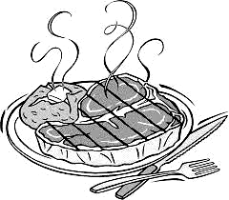 |  | 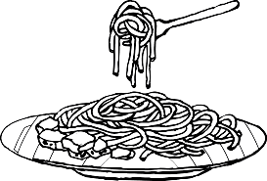 |  | 24  % | (每圖2分)
2 | Phrases | 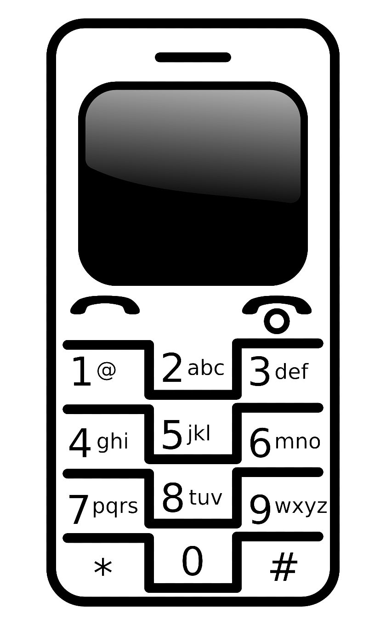 |  |  | 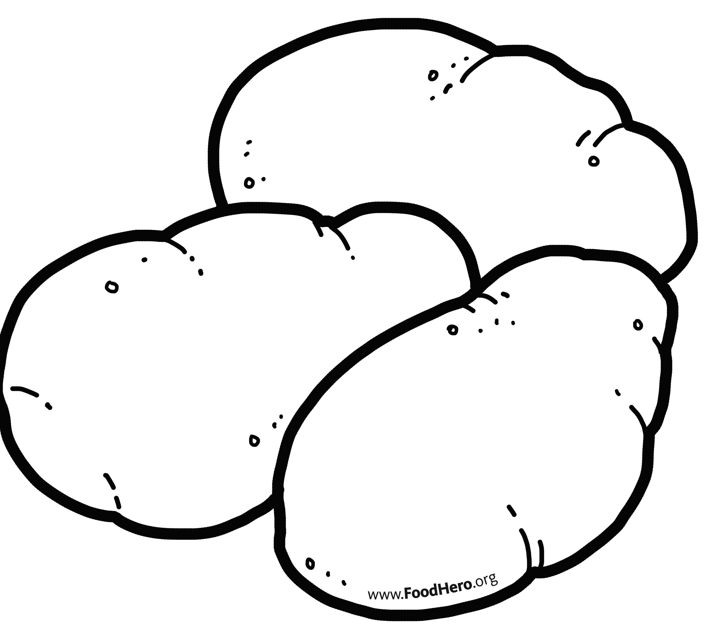   |  | 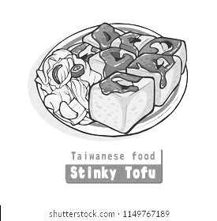 |  |  |  | 24  % | (每圖2分)
2 | Phrases | 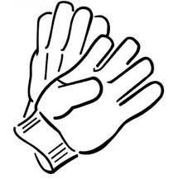 |  |  |   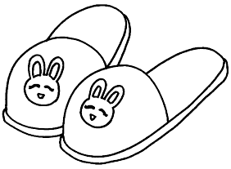 |  |  |  |  |  | 24  % | (每圖2分)
2 | Phrases | 酸 甜 辣 鹹 |  |  |  |  | 我的/你的/他的/她的東西 |  |  |  | 16  %
2 | Q&A | A | How does the tomato soup taste? |  |  |  |  |  |  |  | 7%
2 | Q&A | B | Are these Henry’s slippers ?   ☑我的 |  |  |  |  |  |  |  | 8%
家長簽章與評語: |  |  |  |  |  |  |  |  | 分數

