000 Class： Number： Name：
KK Phonetic Symbols-4

Listen and write.
寫出聽到的音標與單字。
KK symbols words
- ____________ _________
- ____________ _________
- ____________ _________
- ____________ _________
- ____________ _________
- ____________ _________
No. | Consonants/letters | No. | Vowels/letters
 | [ʤ] ____ |  | [ ɝ ] ___________
 | [ӡ] _____ |  | [ ɚ ] __________
 | [ j ] ____ |  | [ ə ] __________
[e][ i ][aɪ][o][u][æ][ɛ][ɪ][a][ʌ][ɔ][℧][ɔ I ][a ℧]/[ð] [θ] [ʃ] [ ]
- [ʃi] [wɛnt] [tu][ ʤə’pæn] [‘j ɛstɚde].
- [wɪl] [ ju] [ʤɔI n][ ə ] [‘sʌmɚ][kæmp]?
- [hɝ] [‘bɝθde] [kek][wɔz][‘vɛrɪ ] [’jʌmɪ].
- [maɪ] [‘faðɚ] [wɝks] [ɪ n] [ə] [’tɛləvɪӡən][‘steʃən].
- [ðə] [gɝl] [I z] [ðə] [bɛst] [‘ʤʌmpɚ] [ɪ n] [a ℧r] [skul].

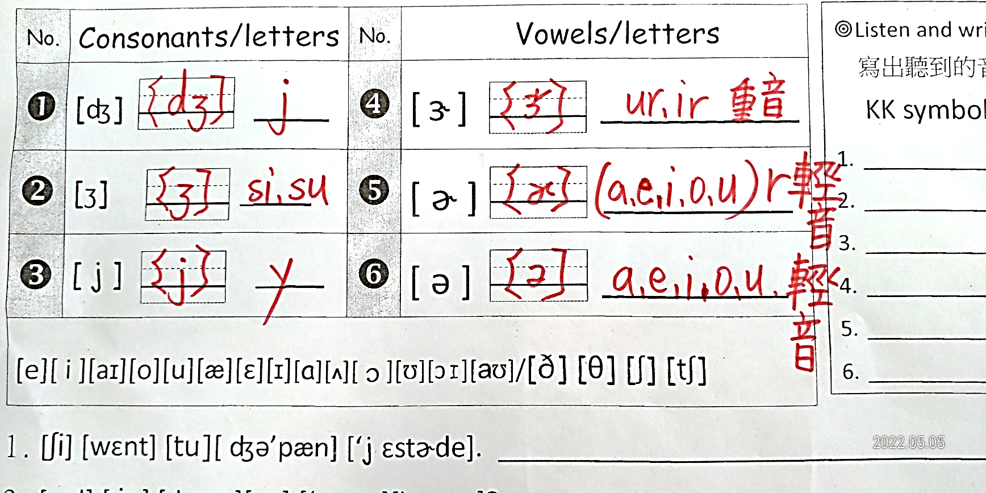

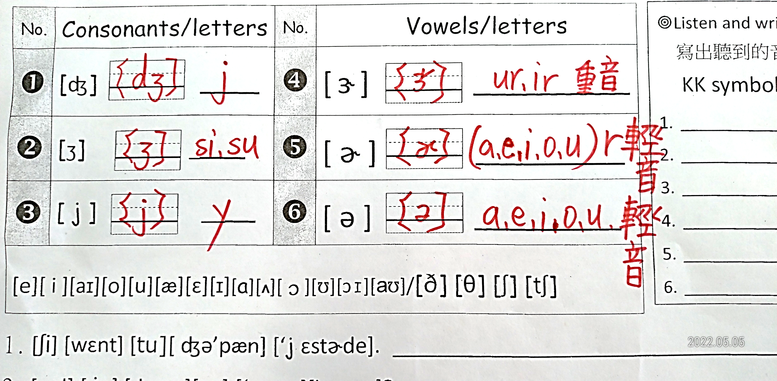

She went to Japan yesterday.

Will you join a summer camp?

Her birthday cake was very yummy.

My father works in a television station.

The girl is the best jumper in our school.

