臺北市內湖區康寧國小110學年度下學期(期末考)六年級
Score分數：
英語科 Class： Number： Name：

A. Listen and choose. 仔細聽，選出聽到的單字或音標。（12%）
❶ [pIrs] [pɝs] ❷ [pæts] [padz] ❸ [ӡ] [ʤ] [ʧ]
❹ ever evil error  tapes taper taped  amber album anchor
家長簽名：

B. Listen and count. 仔細聽單字，選出下列單字音節的數量。（8%）
❶ basketball ____ ❷ notebook ____ ❸ American ____ ❹ give ____

C. Listen and check. 仔細聽，選出人物現在有的東西，所吃的食物與味道。（12%）
 |  |  | 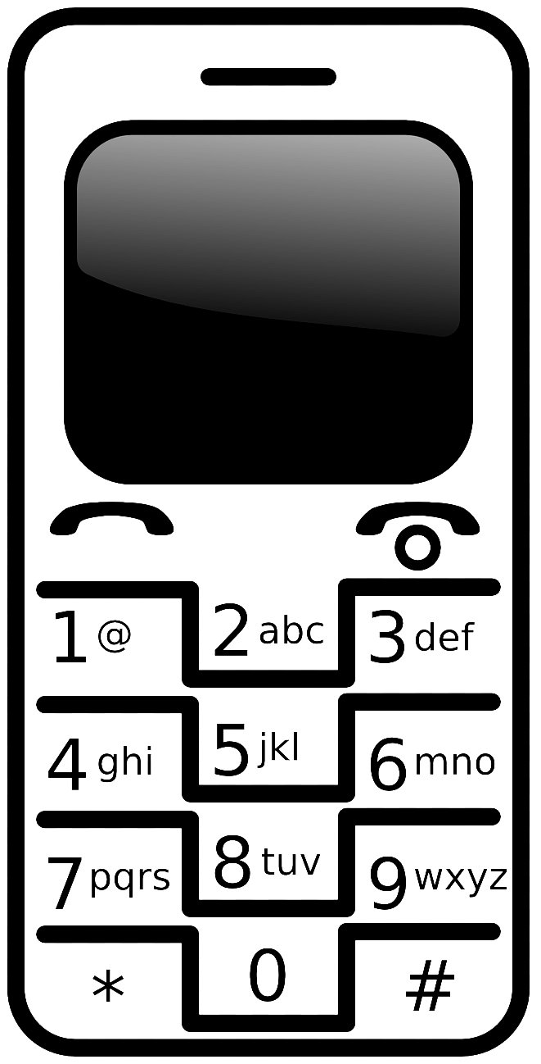 | 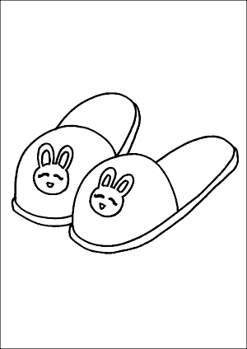 | 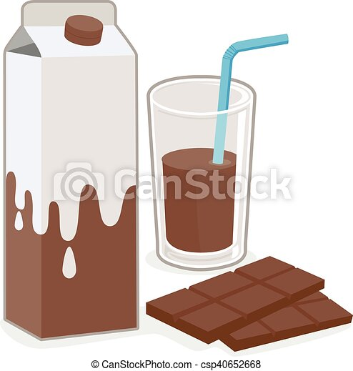 | 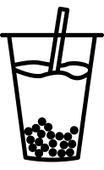 | 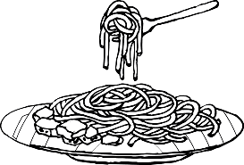 | 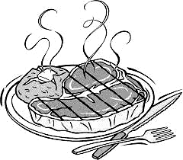 | 鹹的 | 酸的 | 辣的 | 甜的
◆ David
❖ May
⬥ Jim
 Tina
D. Listen and choose. 仔細聽，依據對話，選出正確的答句。（6%）
◆ (a) One teaspoon.

(b) One tablespoon.
(c) One bowl.
❖ (a) Leo’s.

(b) Nancy’s.
(c) Sam’s
⬥ (a) Yes, they’re black.

(b) No, they’re black.
(c) No, they’re red.
E. Listen, read and mark. 仔細聽，敘述內容與下列句子相符合的選True，不符合的選False。
◆ Dad’s wallet is on the floor.

❖ Oliver’s sunglasses are black.

⬥ Peggy doesn’t like the spicy sandwich.

 The tomato soup is poor.

臺北市內湖區康寧國小110學年度下學期(期末考)六年級
英語科 讀寫測驗 Class： Number： Name：
F. Write the correct words. 依提示填入正確的字詞，需自行改變大小寫。（7%）
do be are is his hers does yours mine
1. Whose watch _________ that? It’s _________. Happy birthday, Mary.
2. _________ those your socks? Yes, they’re _________. Thank you.
3. How _________ my breakfast look? It looks yummy.
務必使用上列單字，但並非每一個都會用到，需要時，要改變大小寫。
4. Is this egg your sister’s? Yes, it’s _________.
5. Can your brother _________ my boyfriend? Sure.
G. Fill in the blanks. 將下列左列單字(不可重複使用)填入適當的空格中。（15%）
Anna: Hi, Jack. I __________ my golden retriever, Barbie.
call
lost
finds
collar
steak
fresh phone
waiters
posters
courses
dessert
favorite
excellent Maybe
Could

Jack: Really? It’s too bad. Don’t worry. She has a ___________
with your ___________ number. If someone ________
her, the person will __________ you.
Anna: I made many ___________. ______❼_____ you give some
to your friends? _____❽______ they also can help.
Jack: No problem. It’s lunch time. Let’s go to the new coffee shop
nearby. I went there last weekend. The _____❾_____ was
good. The fruit salad was _____❿_____. The ________
is lemon cake, very creamy.
person 人

Anna: Do they have other main __________?
Jack: Yes, seafood spaghetti. It’s your __________.
The _________ are very friendly.
Anna: Wow, all your comments are __________. Let’s go now.
H. Draw a poster for the dog. 根據上面的對話，另用一張紙，畫一張尋狗海報。（6%）
I. Write the English sentences. 根據中文意思，寫出英文句子。（8%）
Henry的珍珠奶茶嘗起來甜嗎? 不，沒有。它嘗起來很酸。
考試還沒結束喔!
下面還有一張考卷，請繼續作答!
_____________________________________________
_____________________________________________

臺北市內湖區康寧國小110學年度下學期(期末考)六年級
英語科 Class： Number： Name：

J. Read and answer.依據下列內容與提示，使用句子回答後面的問題。（18%）
Sandy has a baby brother, Daniel. She sometimes takes care of him. When he’s hungry, she adds some hot water in a pot and puts his milk bottle into it. After thirty seconds, she takes the bottle out and feeds him. She doesn’t use a microwave to heat the milk because it’s not good for a baby.
Daniel is 6 months old now. He can try more food. Yesterday, her mom showed her how to make apple puree. She asked Sandy to wash an apple. Then, she peeled and cooked it. Later, she mashed it with a spoon. She didn’t add any salt or butter in it. She used the spoon to feed Daniel. He liked it very much.
second(s)秒 feed餵食 heat加熱 puree糊

- Whose baby brother is Daniel? (2分)
________________________________________________________
2. What does Sandy put into a pot with hot water? (2分)
________________________________________________________
3. What food did Daniel eat yesterday? (2分)
________________________________________________________
4. Does Sandy use a microwave to heat the milk? (2分)
________________________________________________________
5. Did Daniel eat the food with salt? (2分)
________________________________________________________
6. What can you add to make the food better to eat? (2分)
________________________________________________________
7. Please write the steps to make apple puree. (6分)
________________________________________________________
________________________________________________________
________________________________________________________
________________________________________________________
-The End-

